7.1 - Rational Expressions and Functions

Definition: Rational Expression
A rational expression is an expression of the form pq, where p and q are polynomials and q≠0.

Determine the Values for Which a Rational Expression is Undefined (When the numerator is zero)
ⓐ

ⓑ

ⓒ

Determine the value for which each rational expression is undefined.
ⓐ

ⓑ

ⓒ
Simplify rational expressions - cancel common factors
We usually leave rational expressions in factored form

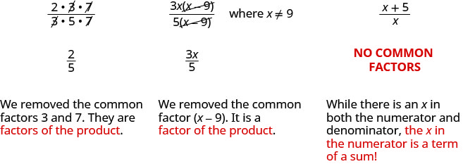

Simplify:

Simplify:

Simplify:
Simplify:

Simplify:

Simplify:

Simplify:

Simplify:

Simplify:

Simplify:

Simplify:

Simplify:

Simplify:

Simplify:

Simplify:
Simplify:

Simplify:
Section 7.2 - Add and subtract rational expressions

Review adding fractions

Simplify:

Simplify:

Simplify:
Simplify:

Simplify:

Simplify:

Simplify:
Review:

Find the LCD for the expressions and

Now rewrite them with their LCD

Simplify:
Simplify:

Simplify:

Simplify:
Simplify:

Simplify:

Simplify:
Be extra careful when there are a lot of negatives

Simplify:

Simplify:

Simplify:
Simplify:

Simplify:

Simplify:
Find (f - g)(x) when and

Find (f - g)(x) when and
Section 7.4 - Solve Rational Equations

Beware of extraneous solutions. You must check to ensure that solutions actually work for the equations when solving rational equations.

Solve:

Solve:

Solve:

Solve:
Solve:

Solve:
Solve:

Solve:
Solve:

Solve:

